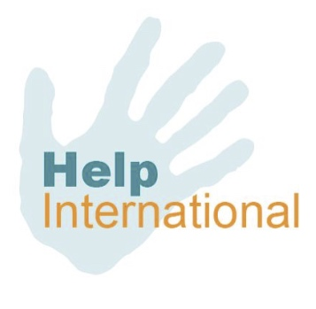
Child Sponsorship - Where does your £20 go?

£20 a month provides a child with a good state education, resources required for schooling, meals throughout the day and in some countries a place to stay.

Out of the £20 monthly sponsorship:

- £5 is invested into our Trust Fund. This Trust fund is a savings account for the child. Once the child has completed their education they will receive a lump sum of the saved donation. Helping to give each child a start as they journey into adult hood.

- £13.50 is given directly to the child for their education costs.

- £1.50 is used for fundraising and administration, which includes bank charges for transfers of funds and communication costs.

Every pound given is distributed by:

- 25p is invested straight into the Trust Fund. The child will receive this at the end of their studies.

- 67.5p is given direct to the child for educational purposes.

- 7.5p is used for fundraising and administration. This allows a communication between sponsor and child to take place.

